|  |  |  |
| --- | --- | --- |
| http://www.hcmus.edu.vn/images/stories/logo-khtn2009_transparency.png | **CS426- Mobile Device Application Development** |  |

Class: APCS 2014

Date: September 16, 2016

**Final Project**

**Group Report**

**Student ID: 1451018**

**Student’s full name: Tô Bạch Tùng Hiệp**

**Email: tbthiep@apcs.vn**

**Tel: 0919531108**

**Student ID: 1451022**

**Student’s full name: Hồ Nhật Hoài**

**Email: hnhoai@apcs.vn**

**Tel: 0902395756**

**Student ID: 1451050**

**Student’s full name: Lê Văn Tâm**

**Email: lvtam@apcs.vn**

**Tel: 01696510480**

# Project Self Assessment

In this section, each student should personally evaluate his or her own effort to complete the project.

* For each feature, please determine the level of complexity (1-Very simple, 2-Simple, 3-Normal, 4-Difficult, 5-Very difficult) and level of completeness (100%).

|  |  |  |
| --- | --- | --- |
| **Feature** | **Complexity** | **Level of completeness**  **(100%)** |
| (A) | (B) | (C) |
| Get data from web to give user updated list about top movie | 4 | 100 |
| Trailer Searching base on YouTube (Input keyword and we will find a trailer of that movie for user) | 5 | 100 |
| Limit the number of result in Trailer Searching | 4 | 100 |
| Share the video link in Trailer Searching (The sharing will let you choose which app to share on your phone) | 3 | 100 |
| Augmented Reality Video when user use camera and point at a movie poster | 5 | 100 |
|  |  |  |
|  |  |  |
|  |  |  |
|  |  |  |

# Advanced Features

Please list in details all ***advanced features*** in your project.

***Screenshots*** are suitable to illustrate these advanced features.

**Augmented Reality Video when user use camera and point at a movie poster**

This advanced feature allows user to scan a poster and it will generate the trailer of that poster’s movie. There ONLY 8 movies that are supported right now so it will only work if user scan poster of that 8 poster. You can use the image in the Misc/Poster (To test Augmented Reality) folder to test this feature. This is very useful for scanning poster when you are in a cinema.

Please notice that the trailer will be load from internet so you need to access to internet in order to test this.

List of supported movie is in Misc/Poster Folder.

For example, we will test poster of kubo and the two strings and storks.

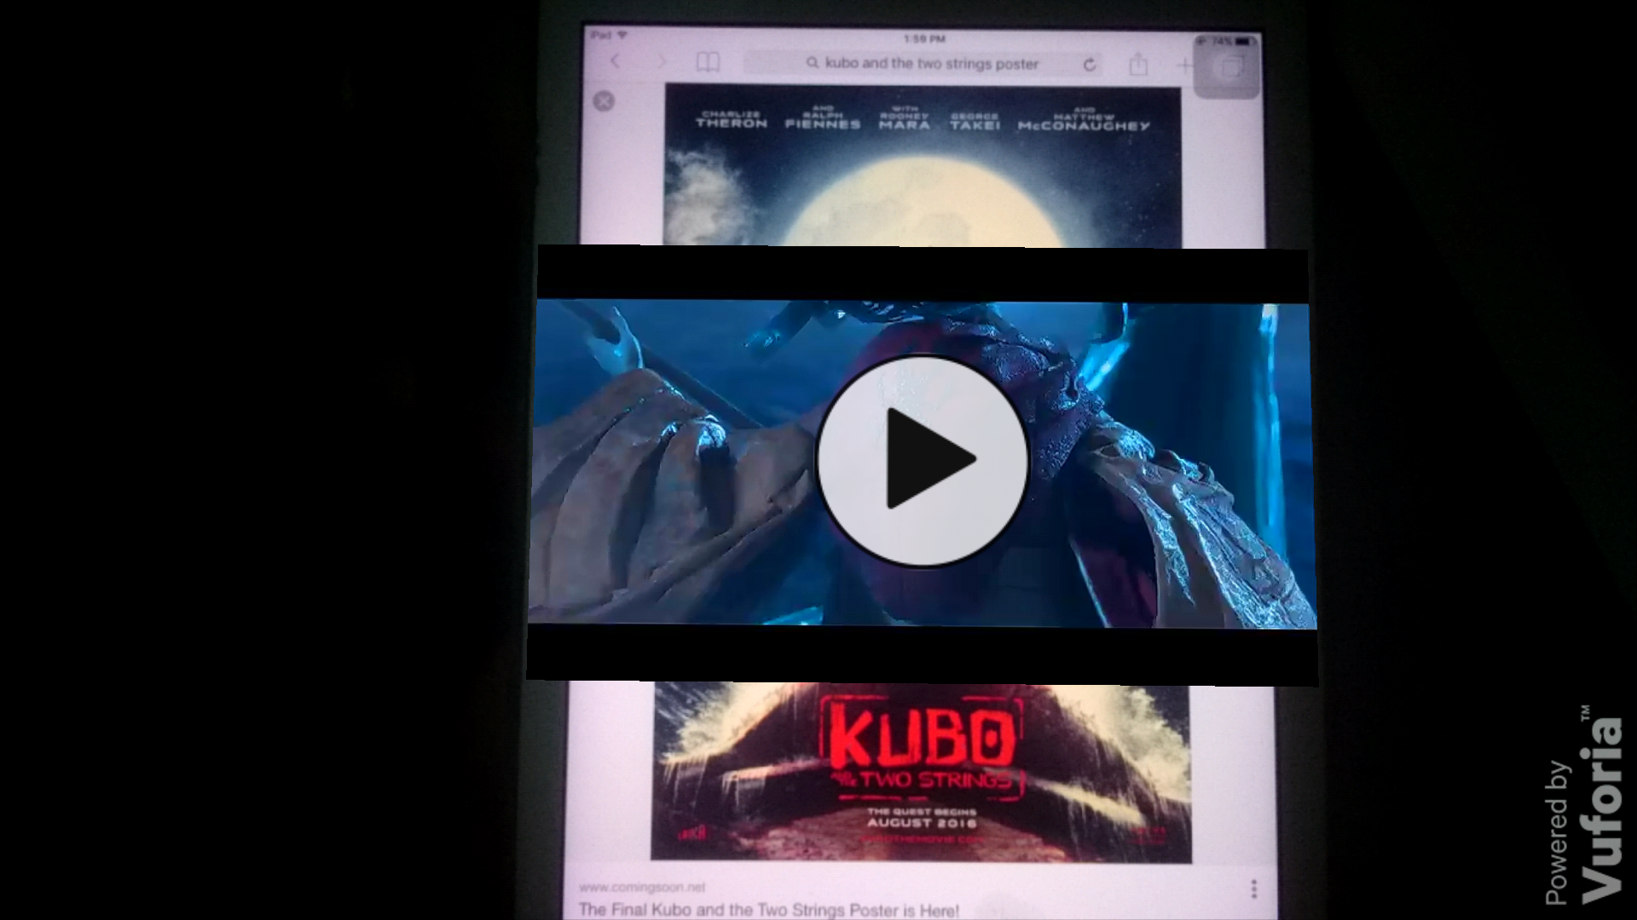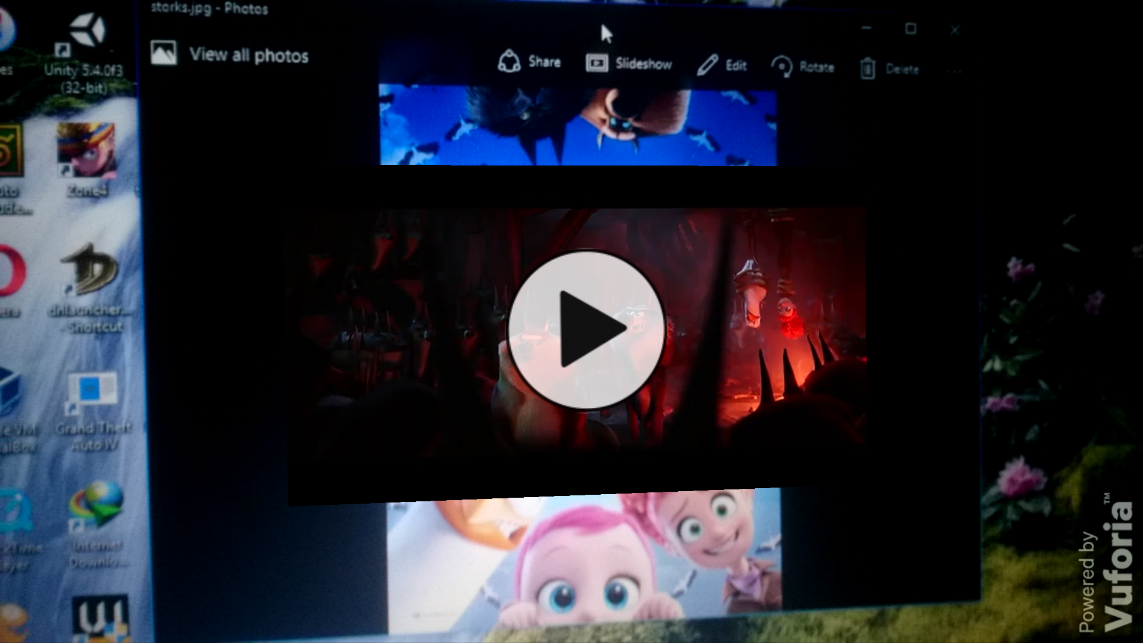

# Screenshots

Please insert ***screenshots*** in this section to illustrate ***all main features*** of your project.

Several screenshots and features ***can be the same*** as in Section II. Advanced Features.

1. **Get data from web to give user updated list about top movie**

We get the data from the website <http://www.fandango.com/rss/moviefeed> to inform user about the latest top 10 budget movie, top upcoming movie and star wars news. From the interface choose top movie. From the top movie’s interface. you can choose your category.

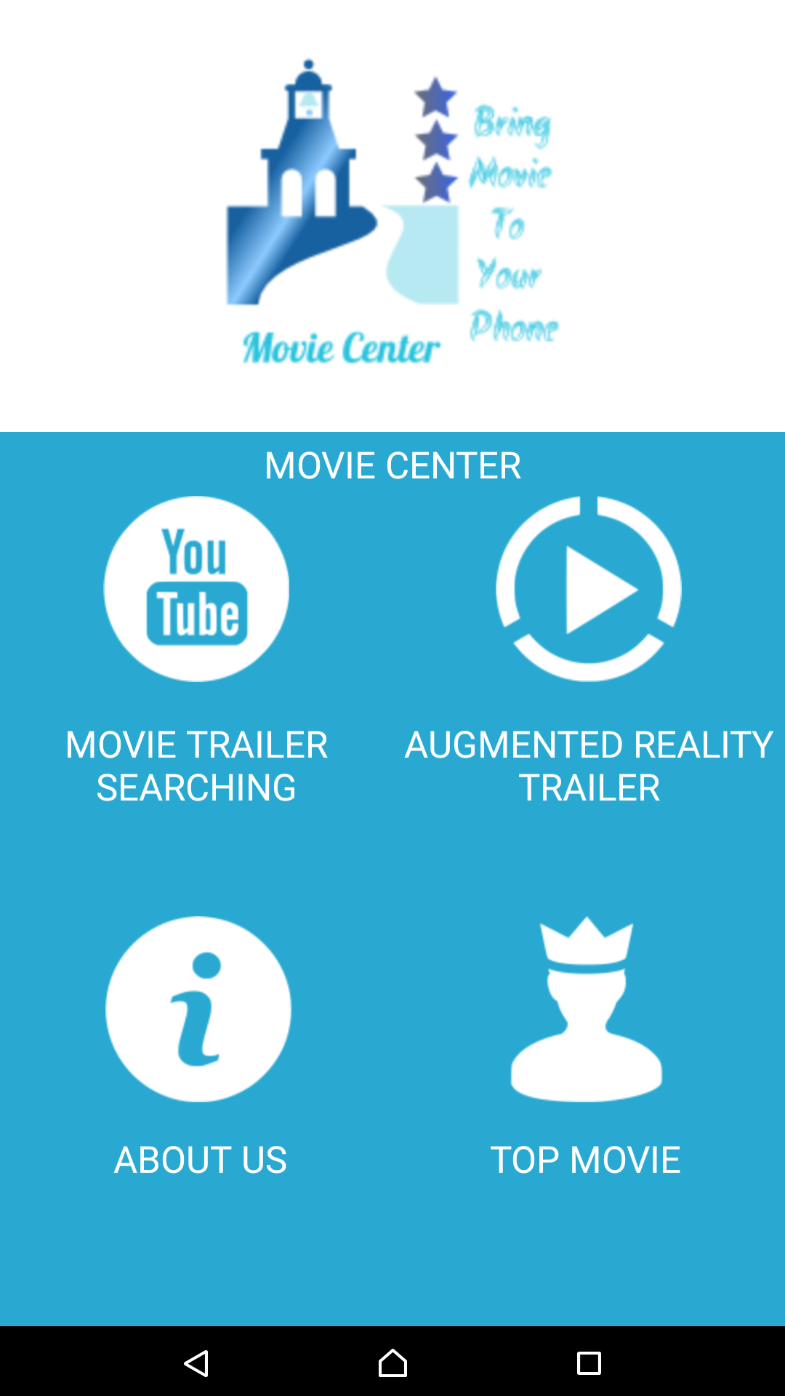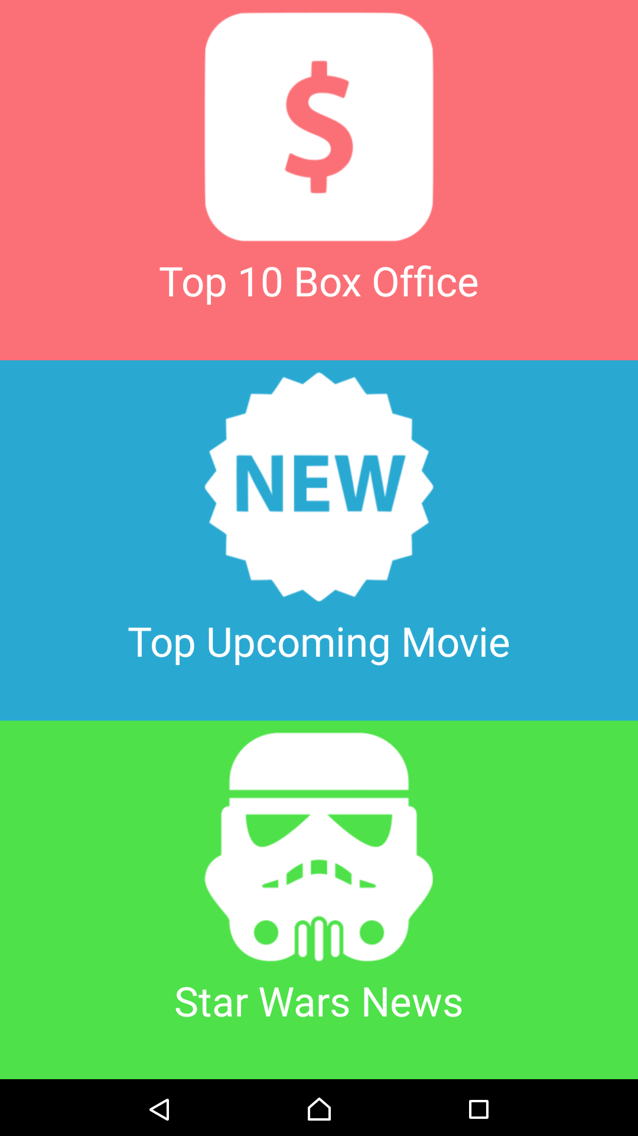

For example, this is what top 10 Box Office looks like. When user click on the picture it will give you the web site to that movie in fandango.com.

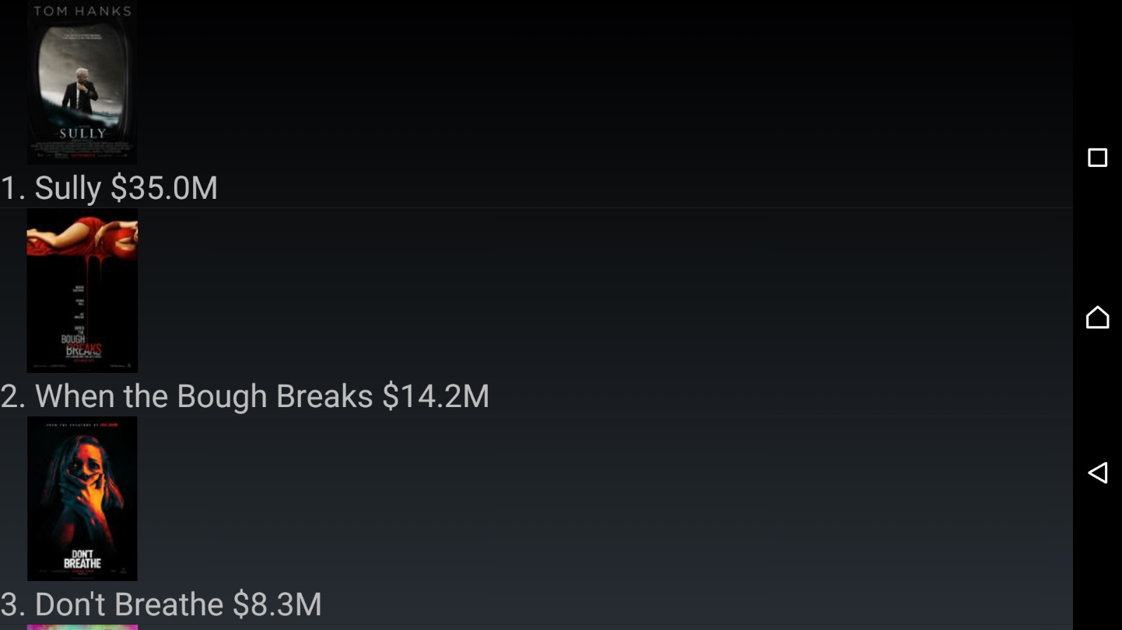

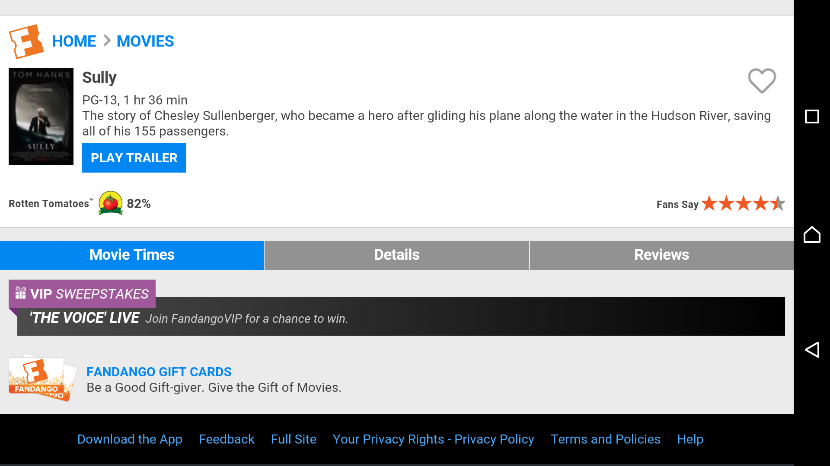

1. **Trailer Searching base on YouTube (Input keyword and we will find a trailer of that movie for user)**

Input **ANY** movie’s name to find a trailer of that movie. It will give user the link in youtube. After that user can click on the video and it will play the video for user (Press done when you enter trailer name and limit so that it will recognize the changes. Press icon search to start. Press the picture to see the video)

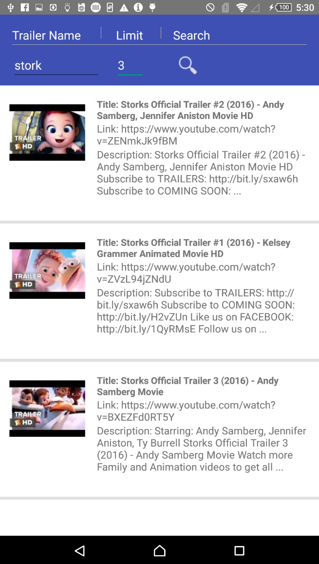

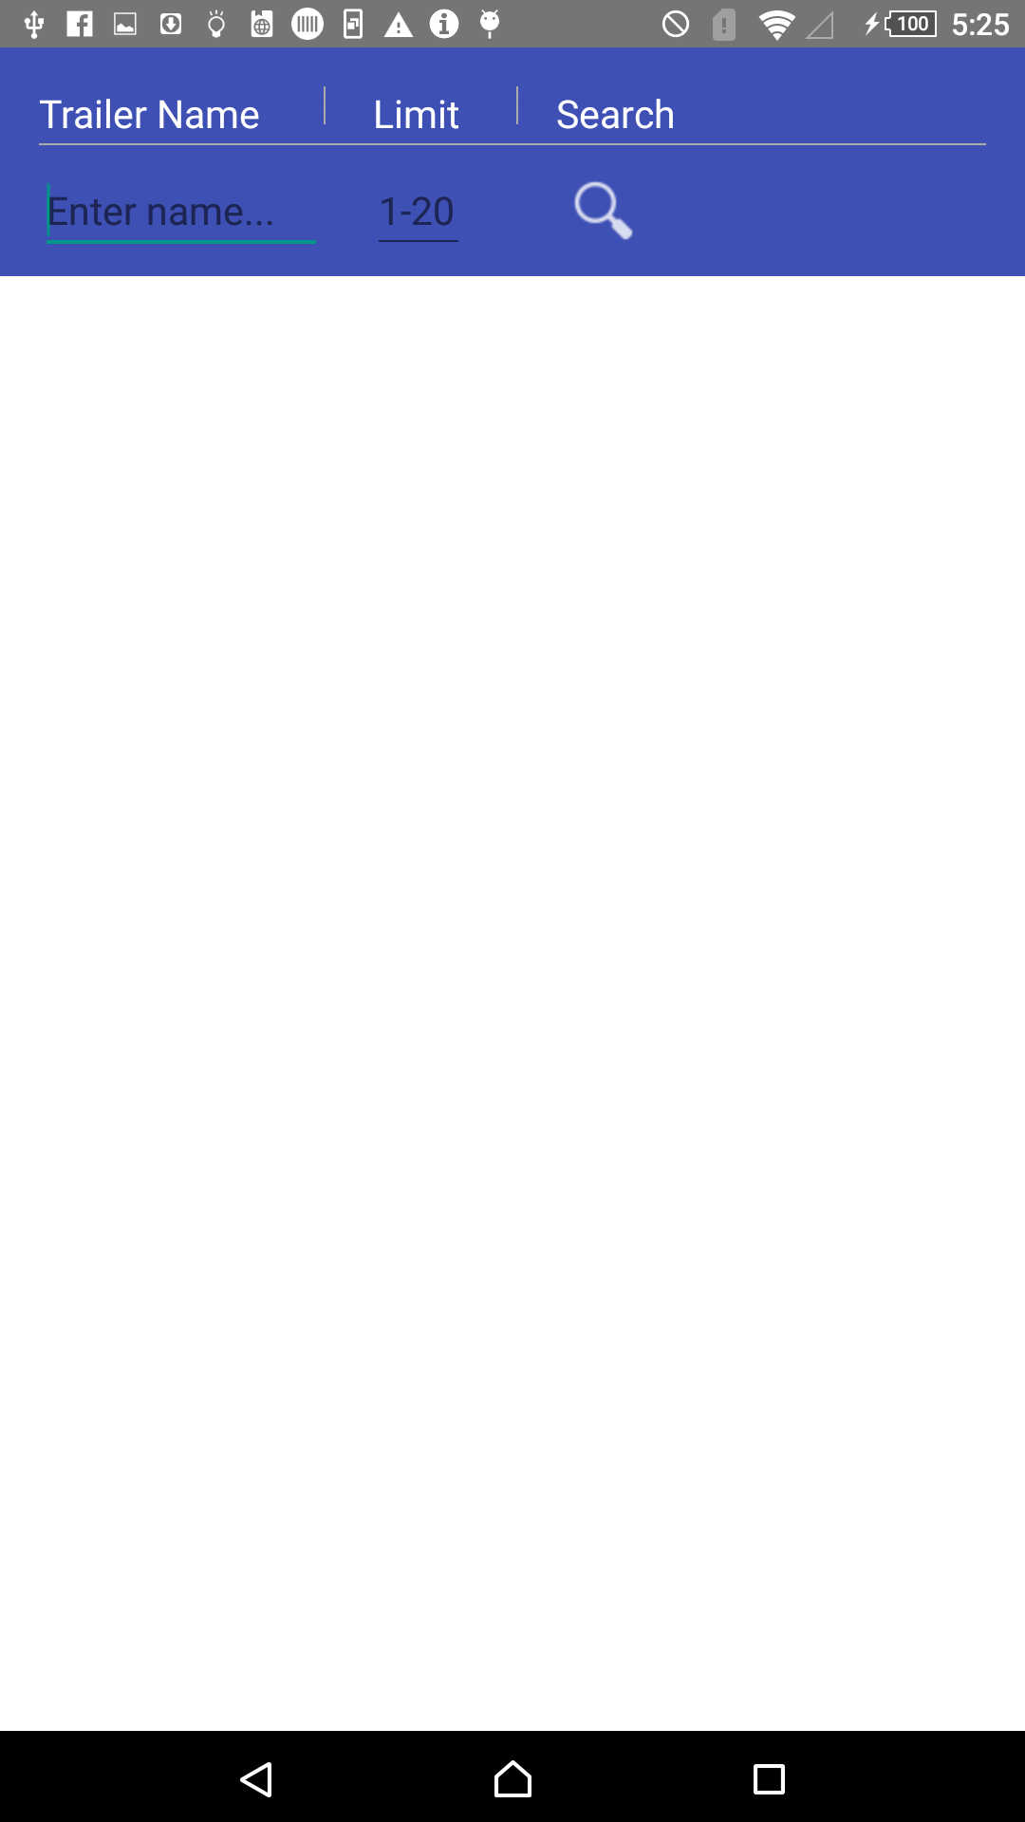

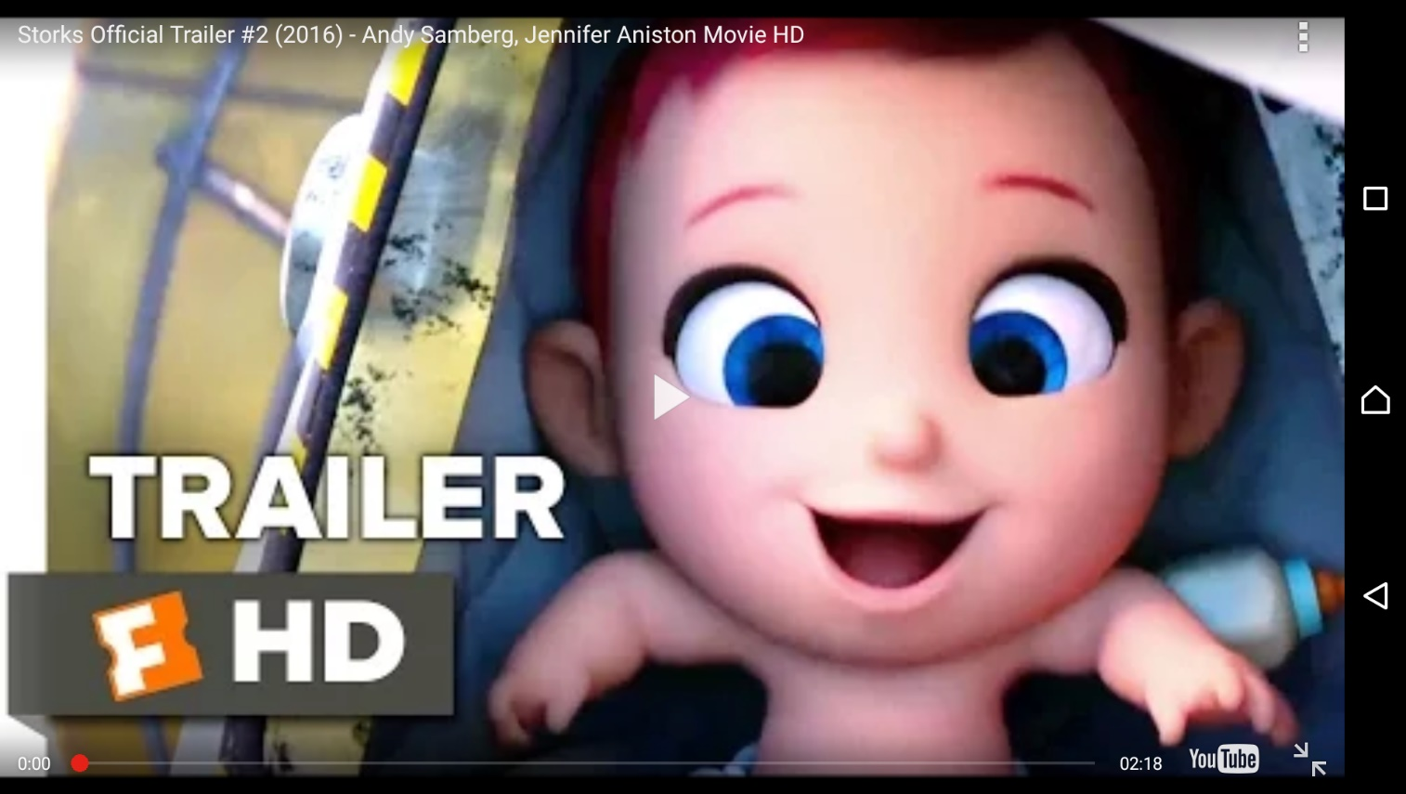

1. **Limit the number of result in Trailer Searching**

Allow user to limit the number of result when search in Trailer Searching from 1-20 (we limit it to 20 because it may make the phone lag if it processes more than 20 video in the list)

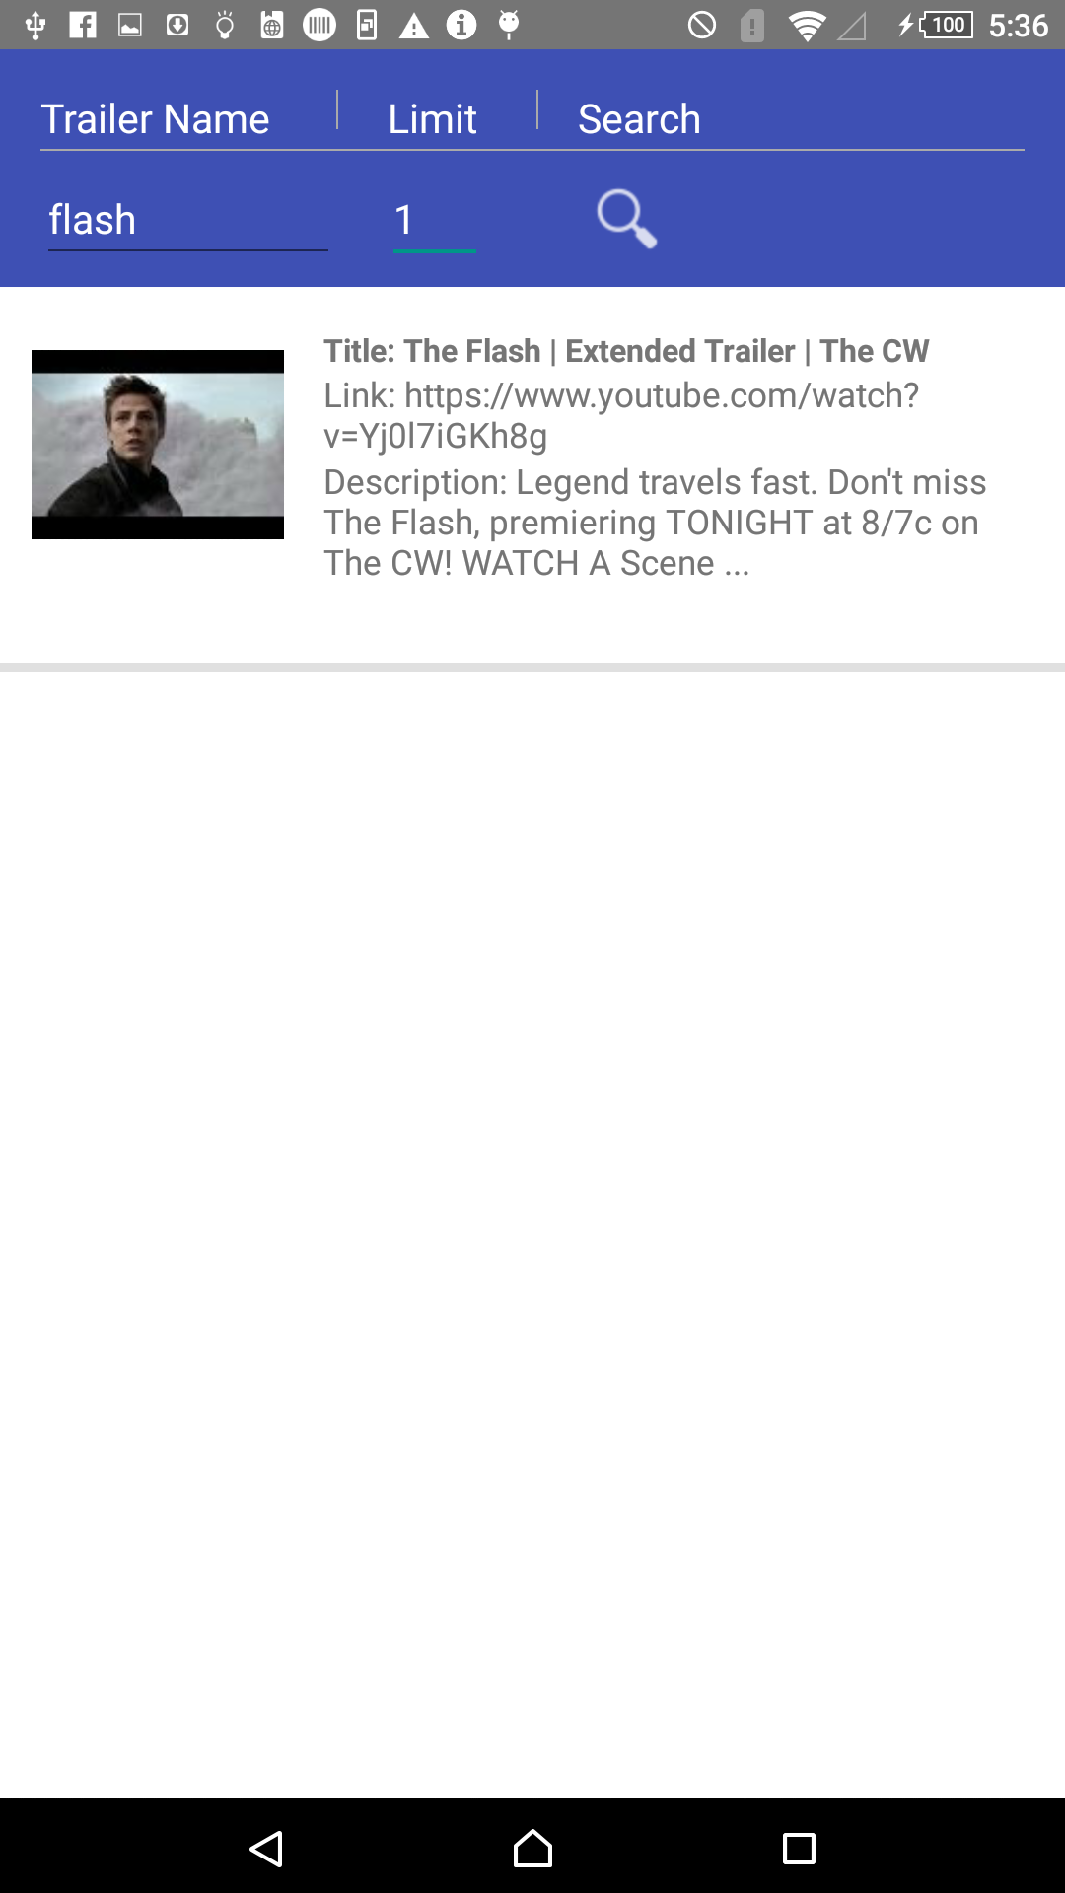

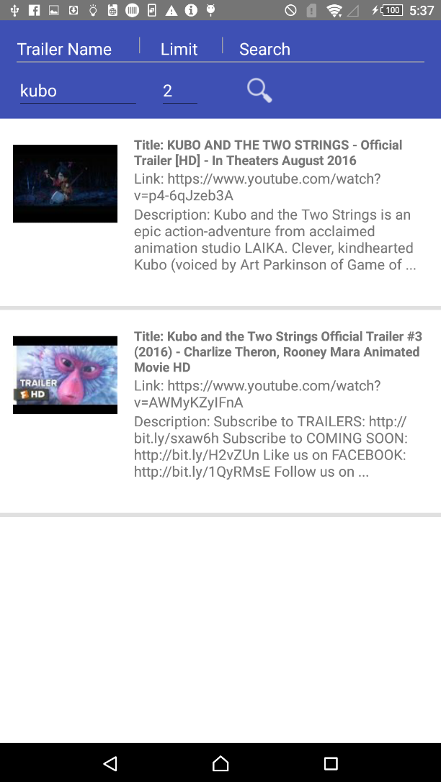

1. **Share the video link in Trailer Searching (The sharing will let you choose which app to share on your phone)**

When you search a video in trailer searching. **Long hold** that video to share the link

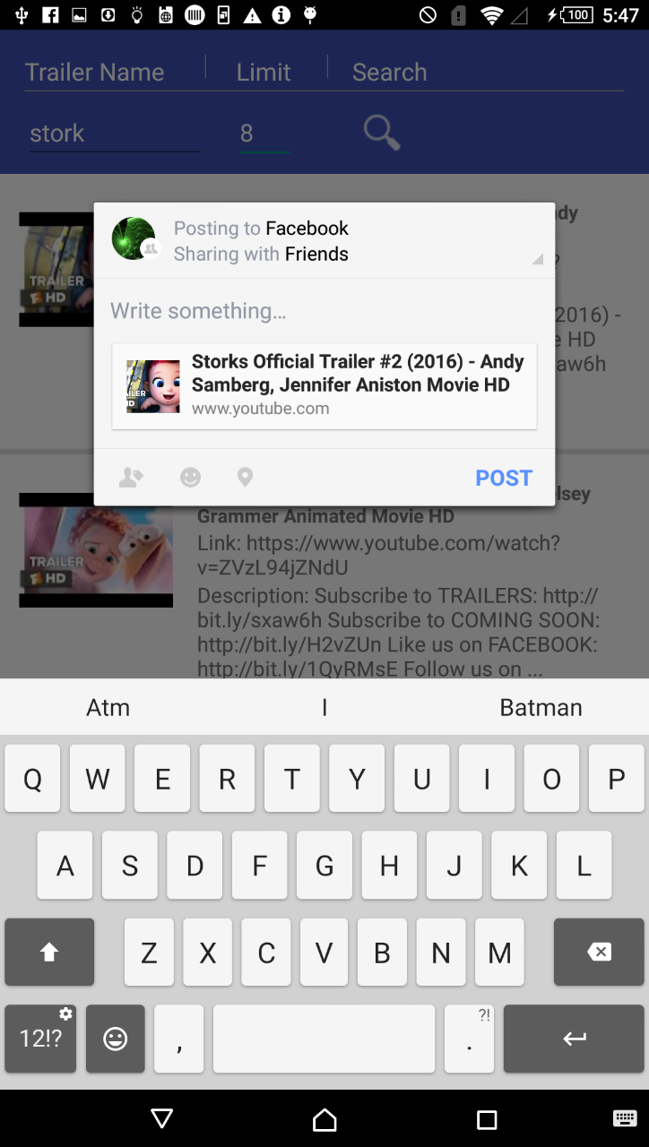

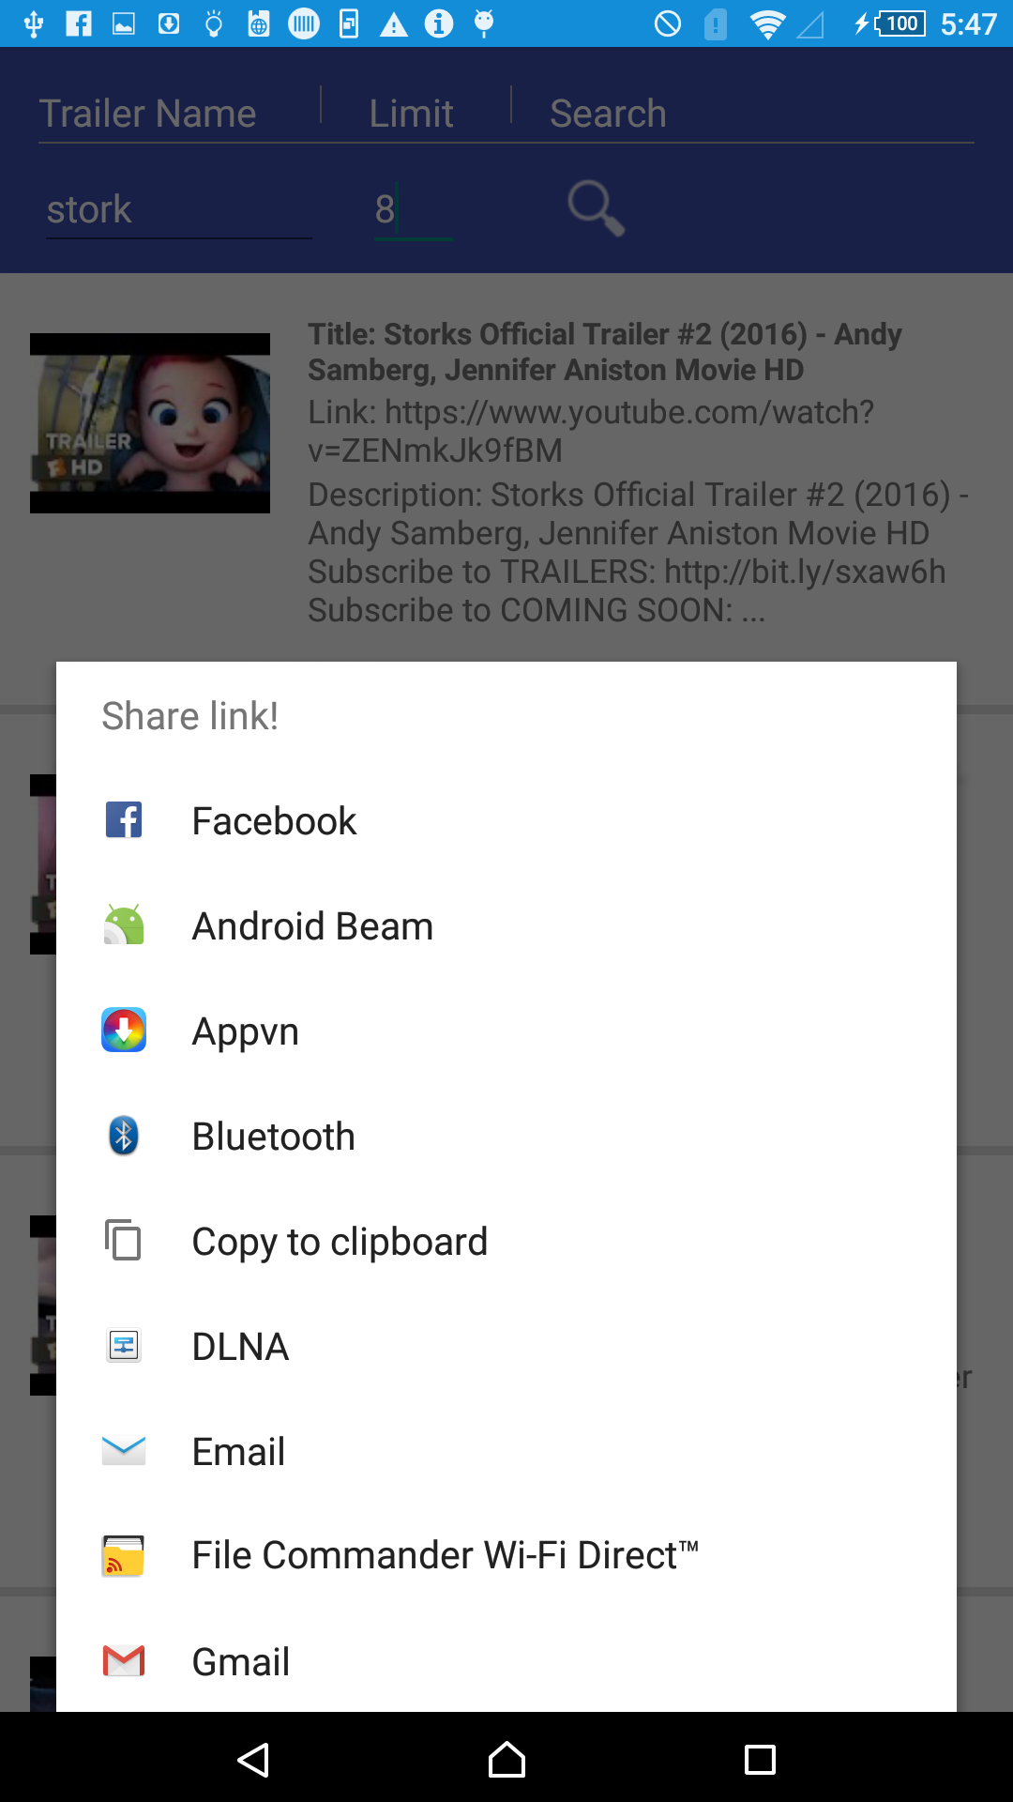

# References

You should list all source codes and/or references that you use in your project in this section.

Any code fragments or libraries that are not yours ***MUST be explicitly declared*** in this section.

If you fail/forget to declare those “inherited” resources, you will be considered “cheating”!

* For Sharing video https://developer.android.com/training/sharing/index.html
* For Trailer Searching

https://codeload.github.com/jakirseu/youtube-api-demo/zip/master

https://codeload.github.com/Keshava11/LatentLoader/zip/master

https://codeload.github.com/appcoda/YouTube-API-Demo/zip/master

* Augmented Reality video base on Vuforia technology https://developer.vuforia.com/target-manager